Comparative Analysis of Carbon Emissions: ICE Vehicles vs. Electric Vehicles

**Viomesh Singh**

*Dept. of Artifical Intelligence and Data Science BRACT’s Vishwakarma Institute of Technology Pune, India*

[*viomesh.singh@vit.edu*](mailto:viomesh.singh@vit.edu)

***Ayush Gude***

*Dept. of Artifical Intelligence and Data Science BRACT’s Vishwakarma Institute of Technology Pune, India* [*ayush.gude22@vit.edu*](mailto:ayush.gude22@vit.edu)

***Anand Deshmukh***

*Dept. of Artifical Intelligence and Data Science BRACT’s Vishwakarma Institute of Technology Pune, India* [*anand.deshmukh22@vit.edu*](mailto:anand.deshmukh22@vit.edu)

***Gautam Warvatkar***

*Dept. of Artifical Intelligence and Data Science BRACT’s Vishwakarma Institute of Technology Pune, India* [*gautam.warvatkar22@vit.edu*](mailto:gautam.warvatkar22@vit.edu)

***Aneesh Deshmukh***

*Dept. of Artifical Intelligence and Data Science BRACT’s Vishwakarma Institute of Technology Pune, India* [*aneesh.deshmukh22@vit.edu*](mailto:aneesh.deshmukh22@vit.edu)

***Shreyas Dhomane***

*Dept. of Artifical Intelligence and Data Science BRACT’s Vishwakarma Institute of Technology Pune, India* [*shreyas.dhomane22@vit.edu*](mailto:shreyas.dhomane22@vit.edu)

****Abstract****—The rapid adoption of Electric Vehicles (EVs) is often presented as a key strategy for reducing transportation emissions. However, the environmental benefits of EVs are highly dependent on the energy grid composition, which varies significantly across Indian states. This study compares the emissions of EVs and Internal Combustion Engine (ICE) vehicles, including Petrol, Diesel, and CNG variants, across multiple states in India. The analysis highlights that EVs achieve the lowest emissions in renewable-energy-rich states like Tamil Nadu and Karnataka but can produce higher emissions than ICE vehicles in coal-reliant states like Jharkhand and Chhattisgarh. Segment-specific comparisons reveal that Two Wheelers (Mopeds and Bikes) and Three Wheelers are the most promising for electrification due to their consistently low emissions across all states. The findings emphasize the need for state-specific energy and transportation policies, including grid decarbonization and tailored vehicle electrification strategies, to ensure a truly sustainable transition to EVs.

**Keywords**—Electric Vehicles (EVs), Internal Combustion Engine (ICE) Vehicles, Carbon Emissions, Coal Dependency, Renewable Energy, Grid Decarbonization, State-Specific Energy Policies, Vehicle Electrification, Two Wheelers, Three Wheelers, Lifecycle Emissions, Sustainable Transportation

# **INTRODUCTION**

The electrification of transportation is a cornerstone of global efforts to mitigate climate change and reduce greenhouse gas (GHG) emissions. Electric Vehicles (EVs) are often presented as a cleaner alternative to Internal Combustion Engine (ICE) vehicles due to their zero tailpipe emissions. However, the environmental benefits of EVs are not uniform across all regions. The emissions from EVs are heavily influenced by the energy grid composition, as the electricity used to charge them can come from renewable or fossil fuel-based sources. This variation in grid energy profiles is particularly significant in India, where state-level differences in electricity generation result in widely varying emissions associated with EVs.

India’s energy grid is a mix of renewable and non-renewable sources, with states like Tamil Nadu and Karnataka relying heavily on renewables, while states like Jharkhand and Chhattisgarh are predominantly dependent on coal. Consequently, the adoption of EVs in coal-heavy states may inadvertently lead to higher overall emissions compared to ICE vehicles, especially those powered by CNG, which has a lower carbon footprint than petrol or diesel.

This study aims to address this gap by conducting a state-wise comparison of emissions from EVs and ICE vehicles in India. By analyzing the emissions across vehicle segments such as Four Wheelers (Sedans and SUVs), Heavy Wheelers (Mini Trucks and Trucks), Three Wheelers, and Two Wheelers (Mopeds and Bikes), this research seeks to identify the suitability of EV adoption in different states.

The study also explores the limitations of EVs in coal-reliant states and emphasizes the role of state-specific policies, grid decarbonization, and segment-specific electrification strategies. By highlighting the interplay between vehicle emissions and energy grid profiles, this research provides a foundation for developing sustainable transportation policies tailored to India’s diverse energy landscape.

# **METHODOLOGY**

#### **Internal Combustion Engine (ICE) Emissions**

**1.1 Vehicle Segmentation and Data Collection**  
The vehicles were categorized into four segments: Four Wheelers, Heavy Wheelers, Three Wheelers, and Two Wheelers. Data on the most popular vehicles for each segment, including their mileage (in km/liter), was collected from official manufacturer websites and automotive platforms. Fuel types considered were Petrol, Diesel, and CNG. Emission factors (in kg CO₂/liter) were obtained from reference [1].

**1.2 Emission Calculations**  
The emission per kilometer for each vehicle was calculated as:

$$E \left(per km\right)= \frac{E (per liter)}{Mileage}$$

**Equation 1**. Calculating EF per km

The Python script automated the following tasks:

* Parsing mileage data for multiple vehicles and averaging across fuel types.
* Computing emission per km for individual vehicles.
* Generating a summary table with average segment-wise emissions.

#### **Electric Vehicle (EV) Emissions**

**2.1 Vehicle Segmentation and Data Collection**  
Data on the range (in kilometers) and battery capacity (in kWh) of EVs was collected for each segment. Sources included manufacturer websites and platforms such as [3] and [5].

**2.2 Efficiency Calculation and State-Level Energy Data**  
The efficiency (in km/kWh) for each vehicle was calculated as:

$$Efficiency= \frac{Range (km)}{Battery Capacity (kWh)}$$

**Equation 2**. Calculating efficiency of vehicle

Python scripts were used to:

* Process state-wise electricity generation and emission data from [2].
* Compute the emission per kWh for each state:

$$E \left(per kWh\right)= \frac{Total Emissions (kg CO2)}{Electricity Produced (kWh)}$$

**Equation 3**. Calculating EF per unit electricity produced

* Calculate emission per km for EVs:

$$E \left(per km\right)=\frac{E (per kWh)}{Efficiency (\frac{km}{kWh})}$$

**Equation 4**. Calculating EF per unit distance

**2.3 Averaging Across Segments**  
Python scripts automated:

* Efficiency calculations for all vehicles in a segment.
* Averaging emissions per km for each segment across states.

#### **Comparison**

**3.1 Histogram Analysis**  
Histograms were generated using Python’s visualization libraries (e.g., Matplotlib, Seaborn) to compare emissions across states for different fuel types (Petrol, Diesel, CNG, Electricity) and vehicle segments.

**3.2 Segment-Specific Insights**  
Python’s data analysis capabilities enabled:

* Identification of state-specific trends in emissions.
* Segment-wise visualization for vehicles like Sedans, SUVs, and Trucks.

# **RESULTS AND DISCUSSION**

This section presents the comparative carbon emissions for Electric Vehicles (EVs) and Internal Combustion Engine (ICE) vehicles across Indian states, segmented by vehicle types. The analysis incorporates figures that visualize the trends and highlights states with zero emissions due to electricity importation (e.g., Goa and Kerala), where emissions data could not be verified or included.

#### **Four Wheelers**

##### **1.1 Sedans**

The emissions from Sedans highlight a clear distinction between EVs and ICE vehicles:

* **EV Sedans**: States like Tamil Nadu and Karnataka, powered by renewable energy, have the lowest emissions (~0.08 kg CO₂e/km). In contrast, coal-reliant states like Jharkhand and Chhattisgarh exhibit higher emissions (~0.14 kg CO₂e/km).
* **ICE Sedans**: Petrol, Diesel, and CNG emissions remain constant across states due to uniform fuel-based emission factors. Petrol and Diesel Sedans produce ~0.12–0.15 kg CO₂e/km, while CNG Sedans have slightly lower emissions (~0.11 kg CO₂e/km).

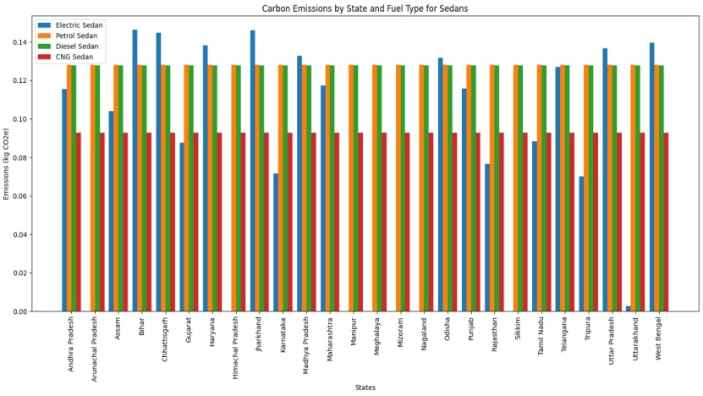

**Figure 1.1** Carbon Emissions by State and Fuel Type for Sedans.

* **Insight**: EV Sedans outperform ICE Sedans in renewable-rich states like Tamil Nadu, but in coal-dependent states like Jharkhand, their emissions often exceed those of CNG Sedans.

##### **1.2 SUVs**

Similar trends were observed for SUVs:

* **EV SUVs**: Lowest emissions were recorded in states like Himachal Pradesh and Tamil Nadu (~0.08 kg CO₂e/km). Coal-dependent states showed emissions as high as 0.16 kg CO₂e/km, making EV SUVs less advantageous in those regions.
* **ICE SUVs**: Diesel SUVs consistently exhibited the highest emissions (~0.15 kg CO₂e/km), followed by Petrol and CNG SUVs (~0.12–0.14 kg CO₂e/km).

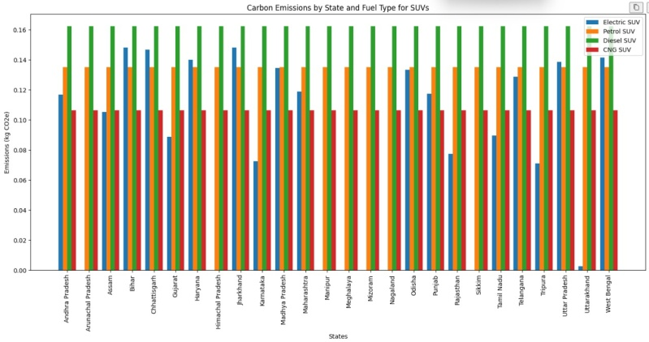

**Figure 1.2** Carbon Emissions by State and Fuel Type for SUVs.

* **Insight**: EV SUVs are the cleanest option in renewable-energy states like Himachal Pradesh, but in coal-dependent states, their emissions can exceed those of CNG and Petrol SUVs.

#### **Heavy Wheelers**

##### **2.1 Mini Trucks**

The emissions of Mini Trucks highlight the suitability of EVs in renewable-energy-dominated states:

* **EV Mini Trucks**: Emissions varied from 0.06–0.12 kg CO₂e/km depending on the state’s energy mix.
* **Diesel Mini Trucks**: Emissions were consistently high at ~0.15 kg CO₂e/km across all states.

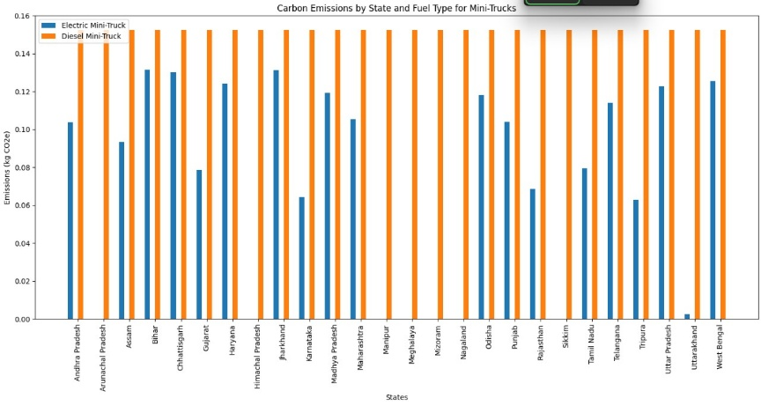

**Figure 2.1** Carbon Emissions by State and Fuel Type for Mini Trucks.

* **Insight**: Electric Mini Trucks outperform Diesel Mini Trucks in renewable-heavy states, with emissions as low as 0.06 kg CO₂e/km, but show comparable emissions in coal-reliant states.

##### **2.2 Trucks**

Truck emissions showed high disparity due to differences in mileage estimation methodologies:

* **EV Trucks**: Emissions ranged from 0.5–0.7 kg CO₂e/km in renewable-heavy states. This mileage estimation was based on engine testing during manufacturing, which may not reflect real-world performance.
* **Diesel Trucks**: Emissions were consistently ~0.4 kg CO₂e/km across states due to more realistic, in-use mileage testing.

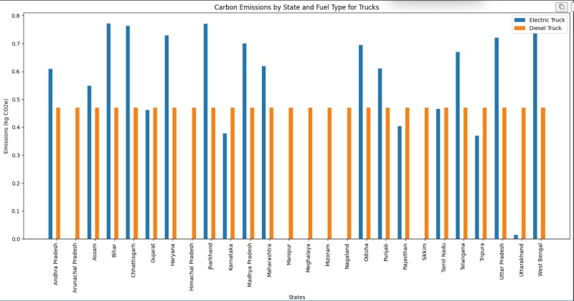

**Figure 2.2** Carbon Emissions by State and Fuel Type for Trucks.

**Insights**: EV Trucks have the potential to outperform Diesel Trucks in terms of emissions, but standardized mileage testing is needed to ensure fair comparisons.

#### **Three Wheelers**

Three Wheelers demonstrated a clear advantage for electrification:

* **EV Three Wheelers**: Emissions were significantly lower, ranging from 0.04 kg CO₂e/km in renewable-heavy states to 0.06 kg CO₂e/km in coal-reliant states.
* **Diesel and CNG Three Wheelers**: Emissions remained constant across states (~0.08–0.09 kg CO₂e/km).

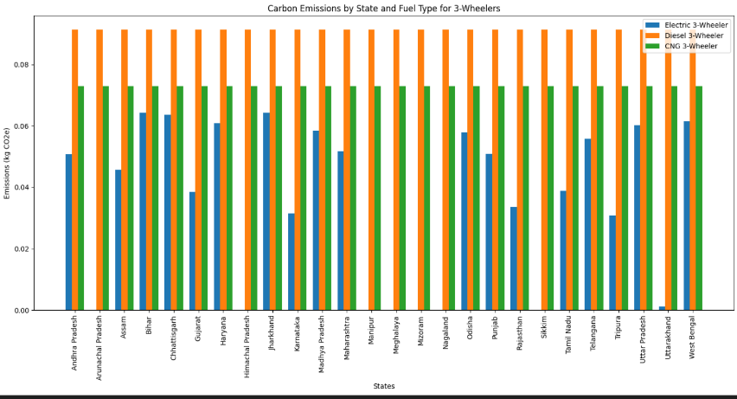

**Figure 3.1** Carbon Emissions by State and Fuel Type for Three Wheelers

**Insights**: EV Three Wheelers are the most viable segment for electrification, offering consistent emission reductions across all states.

#### **Two Wheelers**

##### **4.1 Mopeds**

Electric Mopeds consistently outperformed Petrol Mopeds:

* **EV Mopeds**: Emissions were lowest in states like Tamil Nadu and Karnataka (~0.01–0.03 kg CO₂e/km).
* **Petrol Mopeds**: Emissions were consistently higher at ~0.05 kg CO₂e/km across states.

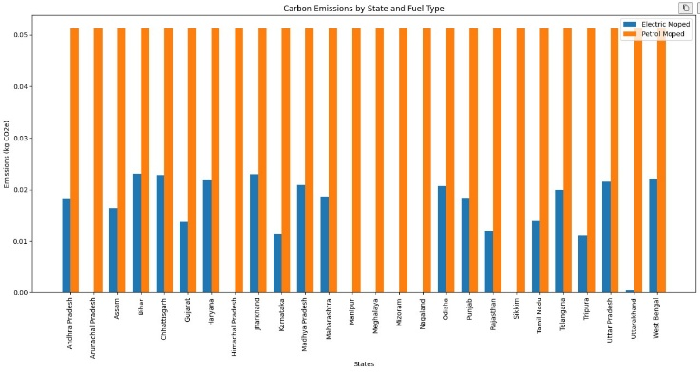

**Figure 4.1** Carbon Emissions by State and Fuel Type for Mopeds.

* **Insight: Electric Mopeds outperform Petrol Mopeds across all states, with emissions as low as 0.01–0.03 kg CO₂e/km in renewable-heavy regions like Tamil Nadu and Karnataka.**

##### **4.2 Bikes**

Bikes followed similar trends as Mopeds:

* **EV Bikes**: Emissions ranged from 0.01–0.03 kg CO₂e/km in renewable-energy states, with slightly higher values in coal-dependent states.
* **Petrol Bikes**: Emissions remained constant at ~0.05 kg CO₂e/km across states.

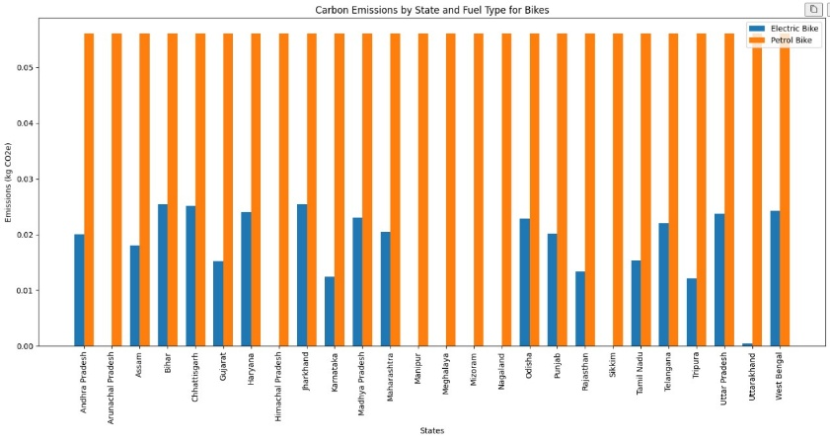

**Figure 4.2** Carbon Emissions by State and Fuel Type for Bikes.

**Insights**: Electric Two Wheelers, including Mopeds and Bikes, offer substantial emission reductions and are highly recommended for widespread adoption.

### **Notes on Zero Emission States**

For states like Goa and Kerala, where grid electricity emissions were reported as zero due to energy imports, data could not be included in the analysis. As reliable government or verified sources for imported electricity emissions are unavailable, these states were excluded from the emission comparisons.

### **Summary of Observations**

1. **State Influence**: The energy grid's composition heavily impacts EV emissions. Renewable-rich states like Tamil Nadu, Karnataka, and Himachal Pradesh are ideal for EVs, while coal-reliant states like Jharkhand and Chhattisgarh see higher emissions from EVs due to carbon-intensive electricity.
2. **Segment Viability**: Two Wheelers and Three Wheelers are the best candidates for electrification across all states, as they consistently emit less than ICE counterparts, even in coal-heavy regions.
3. **Coal Dependency**: In coal-reliant states, EVs, particularly heavier vehicles like Trucks, can emit more CO₂e than CNG or Diesel vehicles, undermining their environmental benefits. Electrification must be paired with grid decarbonization to achieve true sustainability.

# **FUTURE SCOPE**

The proposed system lays a robust foundation The findings of this research underline the critical importance of integrating state-specific energy policies with the electrification of the transport sector. While Electric Vehicles (EVs) demonstrate environmental benefits in renewable-rich states, their viability in coal-dependent regions remains a challenge. Future work can focus on addressing the following areas:

1. **Grid Decarbonization**:

Prioritize renewable energy adoption in coal-heavy states to lower the emission factor of electricity generation. This can enhance the overall sustainability of EVs nationwide. Investigate the role of decentralized renewable energy sources, such as solar-powered EV charging stations, to reduce dependency on coal-fired electricity.

1. **State-Specific Policy Development**:

Formulate tailored policies to promote EV adoption in renewable-heavy states while encouraging CNG vehicles as an interim solution in coal-reliant regions.Provide state-wise incentives for renewable energy integration to support EV infrastructure development.

1. **Lifecycle Emissions Analysis**:

Expand research to include a comprehensive lifecycle assessment of EVs and Internal Combustion Engine (ICE) vehicles, considering battery production, recycling, and disposal impacts.Investigate alternative battery technologies with lower environmental footprints.

1. **Standardized Testing for EV Efficiency**:

Establish universal testing standards for real-world EV mileage and energy consumption, especially for heavy vehicles like Trucks, to ensure accurate comparisons with ICE counterparts. Develop a national database for verified energy usage statistics across EV segments.

1. **Incorporation of Imported Electricity Emissions**:

Include emissions from imported electricity in future analyses for states like Goa and Kerala, where local electricity generation is minimal. Identifying sources and emission factors of imported power will ensure a more holistic assessment.

1. **Advanced Data Analytics**:

Leverage machine learning and advanced analytics to predict state-wise EV adoption patterns and their long-term environmental impacts under various grid scenarios. Simulate the impact of grid decarbonization on vehicle emissions to assist policymakers in identifying high-priority interventions.

1. **Exploring Alternatives to Coal**:

Investigate the role of alternative fuels, such as hydrogen, for sectors and regions where EVs are not currently viable due to high electricity emissions. Promote research on hybrid solutions, like Plug-in Hybrid Electric Vehicles (PHEVs), as transitional technologies.

By addressing these areas, future research can guide a balanced transition to sustainable transportation, ensuring that EV adoption aligns with state-level energy profiles and environmental objectives.

# **CONCLUSION**

This research highlights the complex interplay between energy grid composition and vehicle emissions, emphasizing the need for a state-specific approach to the adoption of Electric Vehicles (EVs). While EVs offer significant environmental benefits in renewable-energy-rich states like Tamil Nadu, Karnataka, and Himachal Pradesh, their performance in coal-dependent states like Jharkhand and Chhattisgarh is limited due to the high emissions associated with electricity generation from coal.

Key findings underline that electrification alone is not a universal solution to reducing vehicular emissions. In states heavily reliant on coal, Internal Combustion Engine (ICE) vehicles, particularly CNG-powered ones, may provide a cleaner alternative in the short term. Two Wheelers (Mopeds and Bikes) and Three Wheelers, however, remain the most promising segments for electrification due to their consistently low emissions across all states.

The study demonstrates that transitioning to sustainable transportation requires a comprehensive strategy, encompassing:

* Grid decarbonization through renewable energy investments.
* State-specific policies encouraging EV adoption in cleaner grids while promoting ICE alternatives in coal-heavy regions.
* A focus on standardizing testing methodologies and lifecycle emissions analysis to ensure accurate comparisons.

By aligning energy and transportation policies, India can achieve a more balanced, environmentally sustainable approach to vehicular electrification, ensuring long-term benefits for both the environment and society.

# **References**

1. **Carbon Footprint Calculator**  
   Gujarat Climate Change Department, <https://ccd.gujarat.gov.in/carbon-footprint-calculator.htm>
2. **Energy and Electricity Emission Data**  
   ICED NITI Aayog:

1. Power Generation Emissions: <https://iced.niti.gov.in/energy/electricity/generation/co-emission>

2. Power Generation Data: <https://iced.niti.gov.in/energy/electricity/generation/power-generation>

1. **Automobile Data Sources**

**a. Two Wheelers (EV)**: <https://www.bikedekho.com/electric-bikes>

**b. Two Wheelers (ICE)**: <https://www.bikedekho.com>

**c. Four Wheelers (EV)**: <https://www.zigwheels.com/newcars/electric-cars>

**d. Four Wheelers (ICE)**: <https://www.cardekho.com>

**e. Heavy Vehicles (EV)**:

* Olectra Greentech Ltd: <https://olectra.com/>
* Switch Mobility: <https://www.switchmobilityev.com>

**f. Heavy Vehicles (ICE)**: <https://trucks.cardekho.com/>

1. **Emission Factors and Calculations**

1. Energy Statistics 2022: Government of India Reports on Electricity Emissions.

2. Lifecycle Assessment Standards for EV Batteries: International Energy Agency (IEA).

1. **Renewable Energy Policy and Transition Studies**

1. “Grid Decarbonization Strategies in Emerging Economies” – International Renewable Energy Agency (IRENA).

2. “The Role of Electric Vehicles in Decarbonizing Transportation” – World Resources Institute (WRI).

1. **Machine Learning in Energy and Transport**

1. “Predictive Analytics for State-Level EV Adoption” – Journal of Cleaner Production, 2021.

2. “Simulating Renewable Energy Impacts on Grid Efficiency” – Applied Energy, 2022.